FORM 2

THE PATENTS ACT,
1970 (39 of 1970)
&
THE PATENTS RULES, 2003

COMPLETE SPECIFICATION
(See Section 10; rule 13)

TITLE OF THE INVENTION
Wifi Integrated Flow Control Valve
APPLICANTS
S.No | Name | Address
 | Dr.K.Sivanandam | Associate Professor,  Department of Electronics and Communication Engineering,  M.Kumarasamy College of Engineering
 | PRABIKA R | UG Students,  Department of ECE,  M. Kumarasamy College of Engineering,  Karur, India-639113.
 | RITHIKA G
 | SANJITHA R
 | SANTHIGA P
The following specification particularly describes the invention and the manner in which it is to be performed.

Title
Field
1.Sensor Integration:Incorporate sensors capable of accurately measuring the density and moisture levels of pulps and papers. These sensors should provide real-time data to the control system.
2.Control System:Develop a control system that processes the sensor data and determines the optimal water flow rate based on predefined parameters and algorithms. This system should be capable of wireless communication to facilitate remote control.
3. Flow Display :Utilize a liquid crystal display (LCD) to visually present the current water flow rate. This display should be easily readable and provide real-time updates.
4. Data Storage :Implement a data storage mechanism using a local area network (LAN). This allows the system to store the flow data (numerical values) in a local server or drive without relying on external cloud services. Ensure data security and integrity during storage.
5. User Interface :Create a user-friendly interface to enable users to monitor the system status, adjust settings if necessary, and access historical flow data stored in the LAN.
6. Safety Features : Incorporate safety features such as emergency shut-off mechanisms or alarms in case of sensor malfunctions or abnormal system behavior.
By integrating these components, the wireless water flow control system can effectively manage water flow based on pulp and paper conditions, display relevant information, and securely store flow data using LAN connectivity.

Background of the Invention
This system is developed to address the need for efficient water flow control in industrial processes involving pulps and papers. By integrating moisture and density sensors with wireless technology and LAN storage capabilities, the system aims to optimize water usage, enhance production quality, and streamline data management without external dependencies on cloud services.

Objects of the invention
The primary objective of this invention is to provide an efficient and automated solution for controlling water flow in industrial processes involving pulps and papers. By leveraging advanced sensing technology, wireless communication, and LAN-based data storage, the invention aims to optimize water usage, enhance production efficiency, and facilitate data management without reliance on external cloud services.

Summary of the Invention
The proposed invention is a wireless water flow control system designed for industrial processes involving pulps and papers. It automatically adjusts water flow by analyzing the moisture and density levels of the materials. Key features include:

- Automatic Control:The system autonomously regulates water flow based on real-time data from moisture and density sensors, ensuring optimal conditions for production processes.

- Visual Feedback:A liquid crystal display (LCD) provides operators with a clear
view of the water flow rate, facilitating monitoring and control.

- Data Storage:Water flow data, including numerical values, is securely stored using LAN technology on a local server or drive, enhancing data security and accessibility.

- Cloud-free Operation: The system operates independently of external service providers like cloud services, reducing dependencies and ensuring continuity of operations.

- Efficiency and Cost Savings: By optimizing water usage and minimizing waste, the system promotes efficiency and cost savings in industrial operations.

- Environmental Impact: Efficient water management contributes to environmental sustainability by reducing water consumption and promoting responsible resource usage.

Overall, the wireless water flow control system offers a comprehensive solution for managing water flow in industrial settings, combining automation, data management,
and environmental responsibility.

Brief Description of the Drawings
Diagram Description:
The diagram for the wireless water flow control system can include the following components and their connections:
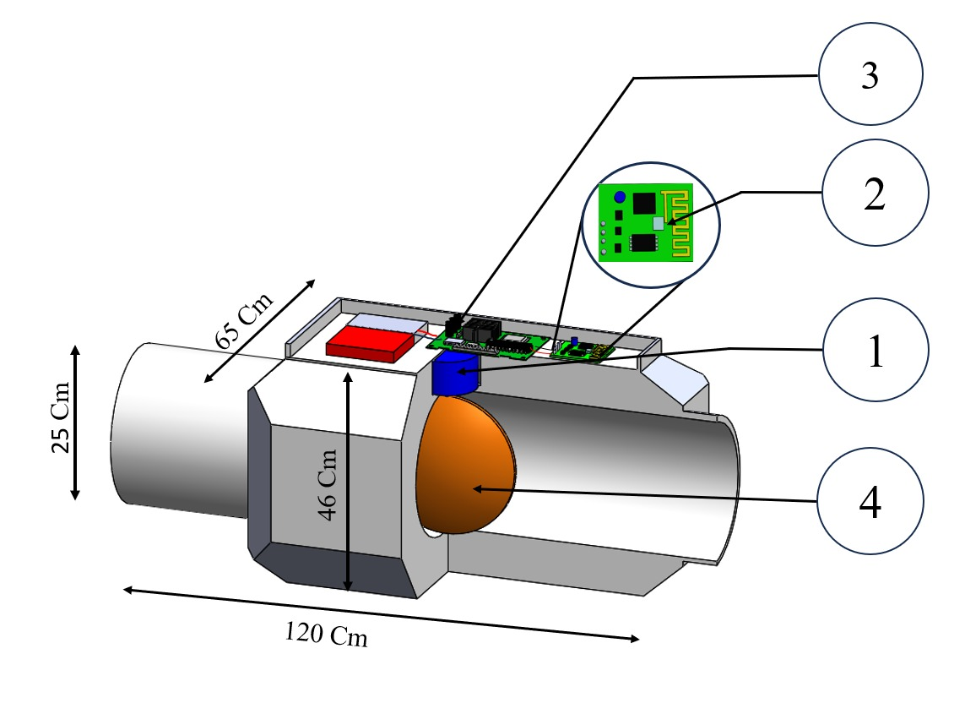
1.Moisture and Density Sensors : These sensors are placed in the vicinity of pulps and papers to measure the moisture and density levels.
2. Wireless Communication Module : This module receives data from the sensors wirelessly and sends commands to control the water flow.
3. Control Unit : The control unit processes the data received from sensors and sends commands to adjust the water flow accordingly.
4. Water Flow Control Valve :This valve regulates the flow of water based on commands received from the control unit.
5. Liquid Crystal Display (LCD) :The LCD displays the water flow rate in real-time, providing visual feedback to operators.
6. LAN Connection :The LAN connection enables data storage on a local server or drive without using external cloud services.
7. Local Server/Drive : This is where the flow data (numerical values) are stored securely.
The diagram should clearly illustrate the flow of data and control signals between these components, showing how the system monitors moisture and density levels, adjusts water flow, displays flow rate, and stores data using LAN. It should also indicate the power supply connections and any additional interfaces or modules required for system functionality.

Detailed Description of the Invention
- Valve Actuator:
  - The heart of the system is the valve actuator, which is equipped with advanced motorized or pneumatic mechanisms.
  - This actuator is designed to fit onto existing valves or can be part of a newly installed valve assembly.

  - It's capable of precise and rapid opening and closing of the valve, allowing for immediate adjustments to fluid flow.
- Wireless Connectivity:
  - The valve actuator is integrated with state-of-the-art WiFi connectivity, enabling seamless communication with local networks.
  - This wireless connection facilitates remote control and monitoring of the valve from any internet-enabled device, such as smartphones, tablets, or computers.
  - The system can also connect to home or office WiFi networks, ensuring compatibility with existing infrastructure.
- Flow Control System:
  - The flow control system consists of sensors and algorithms that monitor and regulate fluid flow.
  - Sensors measure parameters such as flow rate, pressure, temperature, and fluid level, providing real-time data to the control system.
  - Advanced algorithms analyze this data to optimize flow rates, detect abnormalities, and prevent potential issues such as leaks or overflows.
- Control Interface:
  - Users interact with the system through an intuitive and user-friendly control interface.
  - This interface can take the form of a dedicated mobile app, web portal, or desktop application.
  - Through the control interface, users can remotely open or close the valve, adjust flow rates, view real-time data, and set automated schedules or alerts.
- Integration and Compatibility:
  - The system is designed to seamlessly integrate with existing smart home or building automation systems.
  - It can communicate with other IoT devices, allowing for coordinated control and automation of multiple systems within a home, office, or industrial facility.
  - Compatibility with popular home automation platforms such as Amazon Alexa, Google Assistant, or Apple HomeKit ensures a wide range of integration options.
- Security Features:
  - Robust security measures, including encryption, authentication protocols, and secure access controls, safeguard the system against unauthorized access or tampering.
  - Regular firmware updates and security patches ensure that the system remains protected against emerging threats and vulnerabilities.
- Energy and Resource Efficiency:
  - By providing precise control over fluid flow, the system helps conserve energy and water resources.
  - Users can optimize flow rates based on specific needs, reducing waste and lowering utility costs.
  - Automated features such as leak detection and shut-off help prevent water damage and minimize environmental impact.

Claims
I/We Claim,
Here are some potential claims for the invention of an automatic wireless valve integrated with a WiFi flow control system:
1. Remote Control and Monitoring:
  - The invention claims the ability to remotely control and monitor fluid flow through a valve via a WiFi-connected system, allowing users to adjust flow rates and access real-time data from any internet-enabled device.
2. Seamless Integration:
  - The invention claims seamless integration with existing smart home or building automation systems, enabling coordinated control and automation of multiple devices and systems within a network.
3. Advanced Flow Regulation:
  - The invention claims advanced flow regulation capabilities, including precise and rapid opening and closing of the valve, as well as optimization of flow rates based on sensor data and user-defined parameters.
4. Intelligent Automation:
  - The invention claims intelligent automation features such as automated scheduling, alerts, and fault detection, allowing for proactive management and prevention of issues such as leaks or overflows.
5. Energy and Resource Efficiency:
  - The invention claims to contribute to energy and resource efficiency by providing precise control over fluid flow, thereby reducing waste and lowering utility costs.

6.Enhanced Security:
  - The invention claims robust security measures, including encryption, authentication protocols, and secure access controls, to protect against unauthorized access or tampering of the system.

7. Versatile Application:
  - The invention claims versatile application across various industries and environments, including residential, commercial, and industrial settings, for managing fluid flow in systems such as irrigation, plumbing, HVAC, and industrial processes.
8. User-Friendly Interface:
  - The invention claims a user-friendly interface, such as a mobile app, web portal, or desktop application, for easy and intuitive interaction with the system, facilitating setup, configuration, and monitoring.
9. Scalability and Flexibility:
  - The invention claims scalability and flexibility to accommodate different valve sizes, types, and configurations, as well as future expansions or upgrades to meet evolving user needs and requirements.
10.Compliance and Standards:
  - The invention claims compliance with industry standards and regulations related to fluid control and automation, ensuring safety, reliability, and compatibility with existing infrastructure and practices.

Signature of Applicants:
Dr.K.SIVANANDAM | PRABIKA.R | RITHIKA.G | SANJITHA.P | SANTHIGA.P

Abstract

- Introduce a wireless water flow control system designed to regulate water flow based on the moisture and density levels of pulps and papers. Highlight the importance of precise water flow control in paper manufacturing processes to achieve optimal quality and efficiency.
- Describe the flow control mechanism that adjusts water f bw according to real -time moisture and density measurements of pulps and papers.
- Discuss the integration of a Liquid Crystal Display (LCD) to visually represent the current water flow rate.
- Highlight the use of a Local Area Network (LAN) for storing water flow data.
- Outline the advantages of this system, such as improved paper quality, reduced water consumption, and increased operational efficiency.
- Emphasize the environmental benefits of precise water flow control, contributing to sustainable manufacturing practices.
- The integration of a motorized or pneumatic valve actuator with WiFi connectivity enables seamless remote control and monitoring from any internet-enabled device.

